NEW PATIENT APPLICATION FORM
DR. JENNA (DC, CMAP, MA, BA)

Signature: __________________________________ Date: (DD)_______ (MM) ________ (YY)_______

Please circle your reason for today’s visit: Wellness Visit | New Injury | Old Injury | Chronic Pain | MVA | WSIB

How did you hear about us? ______________________________________________________________

Name: _____________________________________ Age: ______ Date of Birth: (DD/MM/YY) ___________________

Address: ________________________________ City: ________________________ Postal Code:__________________

Phone #: (Home) _______________________ (Work) _____________________ (Cell) __________________________

Email: _______________________________ Emergency Contact & Phone #: __________________________________

Occupation & Name of Workplace : ___________________________________________________________________

Spouse: Y/N Children: Y/N Names and Ages: ________________________________________________________

Family Physician: _________________________________ Phone #: ________________________________________

Last Doctor’s Visit: ____________________ Reason: _____________________________________________________

I give my consent to contact my Family Physician to discuss/update my case? Y/N

PREVIOUS HEALTHCARE PROVIDER HISTORY
- Have you had any treatment for this specific condition prior to coming to our office? Y/N
- If so, which type of healthcare pracitioner did you see:
Chiropractor Physiotherapist Massage Therapist Other _______________________________
- When was your last visit with them? ________________________________________________________________
- What condition did they help care for? ______________________________________________________________
- Have you had any X-rays, CTs, MRIs or other medical imaging done before? Y/N
- If yes, which body areas were imaged and when? _____________________________________________________

FAMILY HISTORY

Does anyone in the family have a similar condition? Y/N ________________________________________________

Please circle all that apply, and designate mother’s or father’s side with M/F:

heart disease (M/F) heart attack (M/F) high blood pressure (M/F) cancer (M/F) high cholesterol (M/F) diabetes (M/F) stroke (M/F) arthritis (M/F) osteoporosis (M/F) organ issues (M/F) digestive disorders (M/F) auto-immune disorders (M/F) genetic disorders (M/F)
other diseases: ____________________________________________________________________________________________

Please *CIRCLE* all that apply to your current condition(s) and *UNDERLINE* all that apply to your past conditions.

Headaches Face flushed Shortness of breath Cold sweats
Neck Pain Stiff neck Pins/Needles in Legs Light sensitivity
Sleeping Problems Fatigue Pins/Needles in arms Sound sensitivity
Back Pain Fainting Numbness in fingers/toes Memory loss
Nervousness Depression Vision problems Loss of balance
Tension Ringing in ears Diarrhea Night sweats
Irritability Nausea Constipation Sudden weight loss
Chest Pains Loss of smell Cold hands/feet Night pain
Dizziness Loss of taste Upset stomach Fever/ Chills
Difficulty speaking Wounds Recent infections Menstrual issues
Difficulty swallowing Scars Alleriges Hormonal issues
Digestive issues Concussion Pain with weather changes Urinary issues

DETAIL YOUR PERSONAL CONDITION. PLEASE ANSWER ALL QUESTIONS.

What is your major body area(s) of complaint? ___________________________________________________________

When (date) and how did this begin? __________________________________________________________________

Have you had any similar issues in the past? Y/ N Is this condition mild, moderate, or severe? __________________

Rate the current intensity level of your condition from 1-10 (10 = worst pain you have personally experienced): ______

This condition is: slowly improving / staying the same / getting worse over time / is constant / comes and goes

Which characteristics describe your condition: dull / achy / numb / tingling / pins and needles
stiff / tight / sharp /stabbing / shooting / burning

What activities aggravate your condition? ______________________________________________________________

What activities alleviate your condition? (ex. heat, ice, pain medications, creams, rest, stretching, sitting, moving)
_________________________________________________________________________________________________

Is this condition worse at certain times of the day? _______________________________________________________

Do you have shooting pain that travels up or down? If yes, where? __________________________________________

Do you have pain when you cough or sneeze? If yes, where? _______________________________________________

Are your bowel and bladder habits regular, frequent, and without pain? Y/N __________________________________

What other health conditions or illnesses do you currently have, or have had in the past?
________________________________________________________________________________________________

What medications do you take, including dosages? What are they for? ________________________________________________________________________________________________

What supplements or vitamins do you currently take?
________________________________________________________________________________________________

List ALL surgeries, injuries, fractures and scars (no matter how how long ago):
_________________________________________________________________________________________________ _________________________________________________________________________________________________

*CLINICAL FLAGS (circle all that apply): history of cancer / night sweats / sudden weight loss / recent fever / night pain

PERSONAL AND SOCIAL LIFE

HOW is this condition affecting your work / sleep / hobbies / social life / daily activities?
_________________________________________________________________________________________________

How long is your drive to work? How long do you sit at work? What repetitive activities do you do at work?
_________________________________________________________________________________________________

What repetitive activities do you to at home / from day-to-day?
_________________________________________________________________________________________________

What stresses, illness, life changes or injuries have you experienced in the past year? Approximately when?
_________________________________________________________________________________________________

Has this condition interrupted your sleep?  - Trouble falling asleep due to discomfort Y/N  - Not enough restful sleep Y/N  - Awakening in theh middle of the night Y/N  - Waking earlier than you normally would Y/N  - Average hours of sleep ______________  - Sleeping position ___________________  - Pillow type ________________________ | Women  - Are you taking Brith Control? If so, for how long? _____________  - Are you nursing? Y/N  - Are you pregnant? Is so, how many weeks? _________________  - When was the onset of your last menstrual cycle? ____________  - Do you have children? Y/N How many? __________________  - Type of delivery, and were there any complications? ________________________________________________

What are your TOP 3 goals? What would you be doing more of if you were in a healthier state?
_________________________________________________________________________________________________
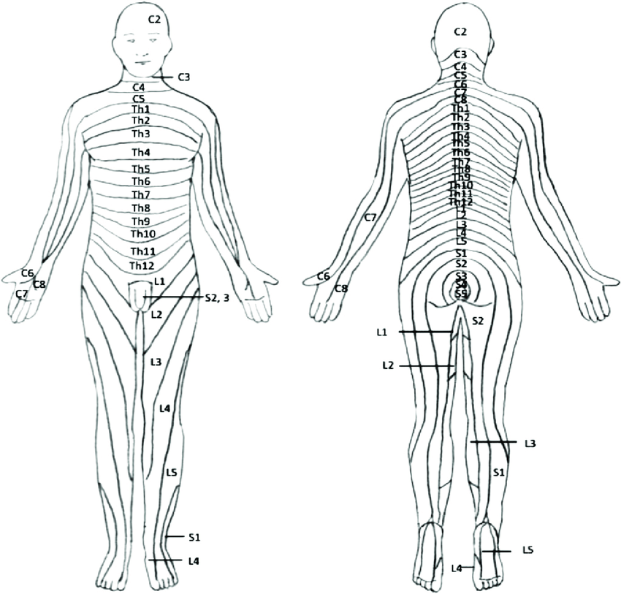

*** DOCTOR’S NOTES ***

